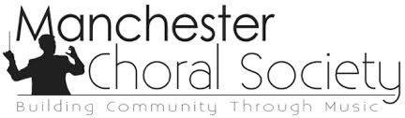

MCS Walk-A-Thon
Sponsorship FAQ and Support
Donation Levels:
- $10: Online Resources, MCS Website
- $25: Marketing and PR costs
- $50: Music for our Musicians
- $100: MCS Singer
- $175: MCS Dues
- $200: Collaborations, Queen City Youth Choir, Manchester Proud, etc.
- $250: Educational Outreach / MCS Scholarship
- $500: Orchestra Seat
- $750: Venue and Rehearsal Space
- $1000: Sectionals for the year

Building Community Through Music
MCS’s community and educational outreach programs:
- Scholarship program
- The re-formation of our youth choir: Queen City Youth Choir, free for students grades 3-6 (Manchester and surrounding communities).
- Collaborations with Manchester Proud, Compass. With this opportunity any high school student in the Manchester area can participate in all aspects MCS for school credit, free of charge.
- Free concert admission for students K-Undergraduate.
- Free community concerts: Caroling at the Currier, various tree lighting ceremonies, Music in the Parks at Stark Park and performing at local assisted living and senior centers.

Make it personal, share YOUR story:
- Why do you sing with MCS?
- What does this experience mean to you?
- What is the importance of building community through music?

About Us:
​Established in 1961, the Manchester Choral Society is a non-profit, auditioned community choir and is proud to be a part of the rich choral tradition that contributes to the cultural community of New Hampshire.

Mission:

The Manchester Choral Society is committed to sharing and promoting the best choral music of a variety of styles and periods through vibrant performances, collaboration, and educational and community outreach. The organization is committed to diversity and inclusion through collaboration with BIPOC artists, as well as the performance and commissioning of works by composers from BIPOC communities (Black, Indigenous, and People of Color).

Vision:
To seek relevance and hope through music
To bring communities together
To promote a sense of unity and peace

